SolicitudGrafica_06_08_REC140 para recurso M14A

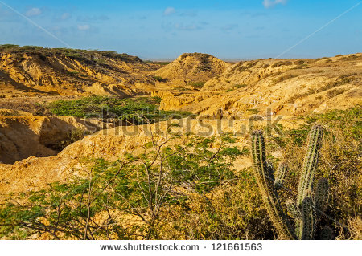121661563

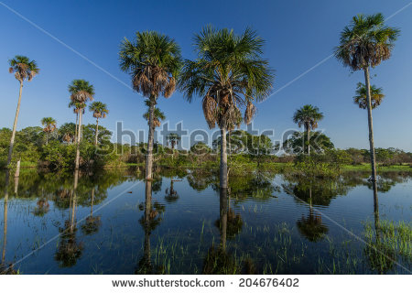204676402

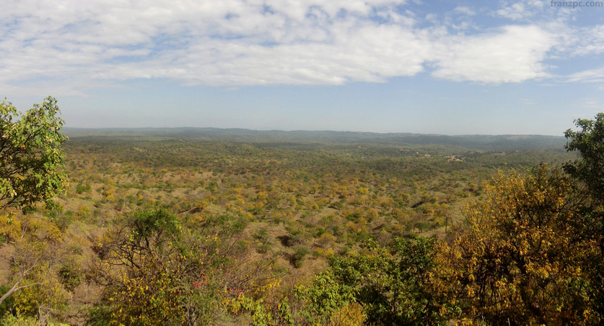<https://www.flickr.com/photos/franzleonardo/5934877768/in/photolist-a3rNoL-6fvN9v-6HGZgP-6fzTgE-71nYth-841MaJ-78H2oC-6e85QV-7wwWEx-6HH58r-b4TbCg-7wAKCU-a3rKrC-6HH7Ez-6K2b2h-hYruSQ-oFz8UD-kdSGP6-oVzGVJ-oXkw5B-oXRTRH-q5NyUr-jSWsLD-6JWUwK-ptcwvJ-pbJPt7-pbMYX1-6JWUwz-qkDV53-o87Fy1-nCJP8i-nN4FHP-pt12Gn-ontFwT-pbMdRg-o4dTxS-o45MRJ-os1dTC-o9myt3-aauRE1-pthkUB-okw8Hj-aauReo-oYnp4r-aauRPo-prfhNU-a6H7AL-os1e5Q-b4SSqH-71nYbd>

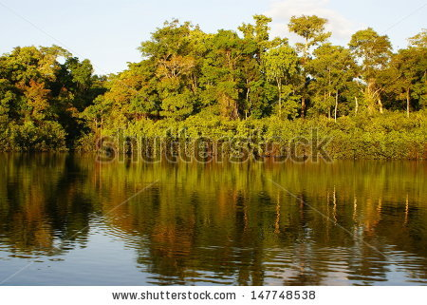147748538

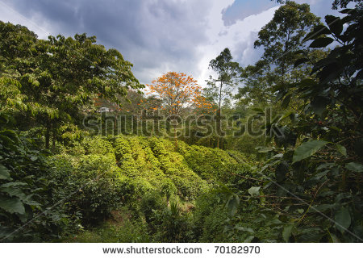70182970

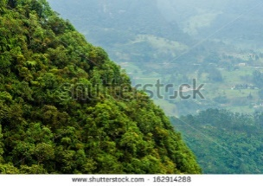162914288

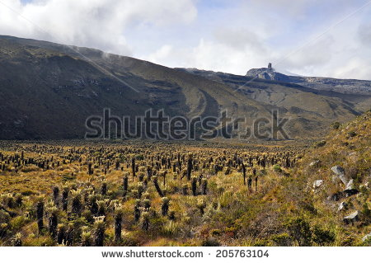 205763104

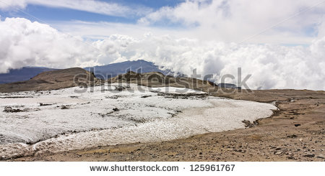125961767